Laura Olivari 876599
REVERSE PENDULUM
m = 80 %[kg] bar mass
J = 20 %[kg*m^2] bar moment of inertia
l = 1 %[m] bar length

STABLE SYSTEM
k=250 %[N/m] stiffness
r=25 %[Ns/m] damping

P-Control
Kp= [10 100 300 1000 5000]
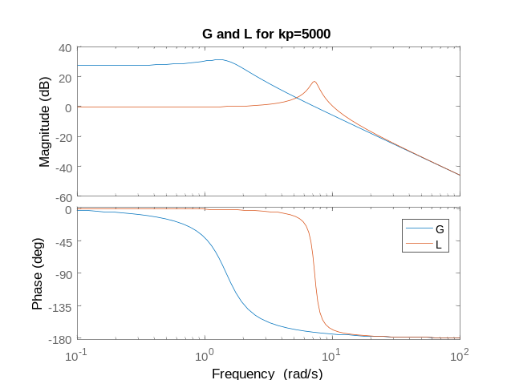
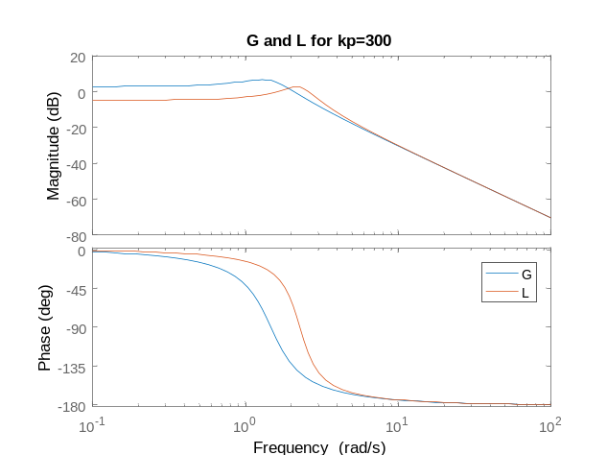
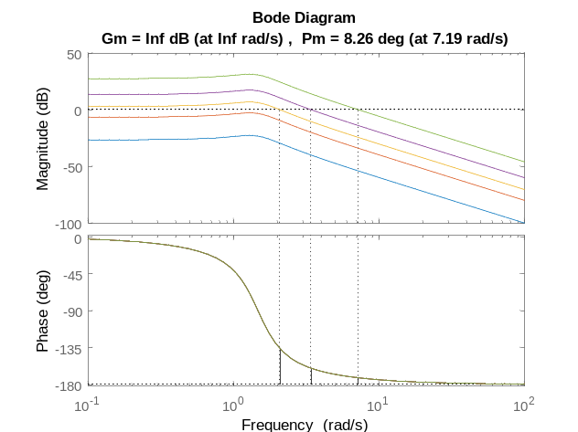
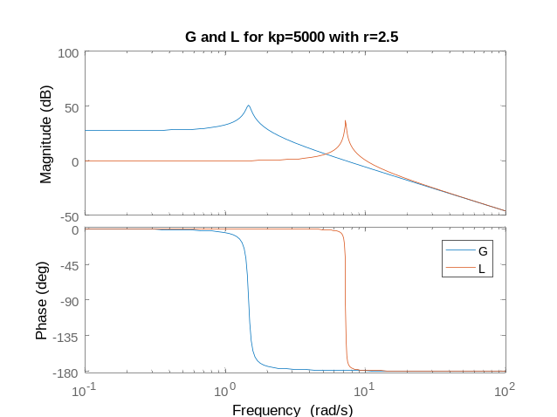
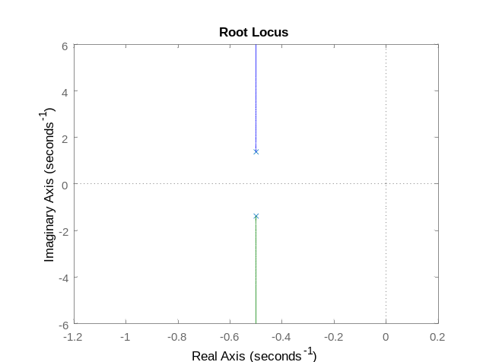
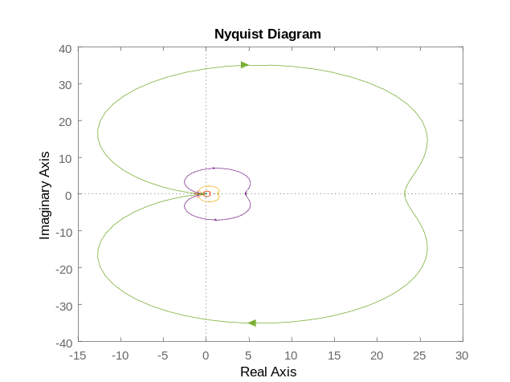

'kp' 'Error' 'Bandwidth'
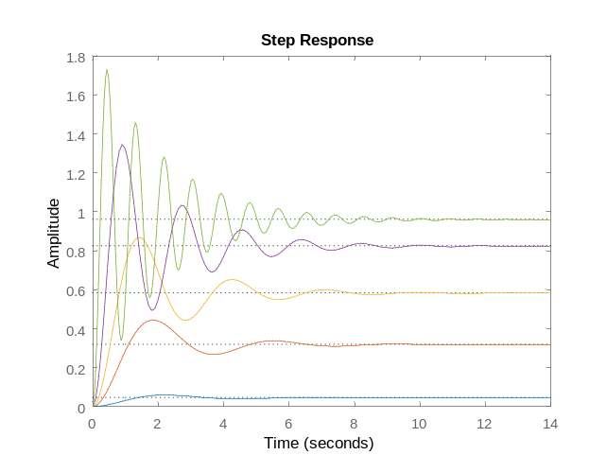
10 0.95559503 2.1450015
100 0.68274112 2.6010635
300 0.41770186 3.4035894
1000 0.17709019 5.3354374
5000 0.041263998 11.178798

PD-Control
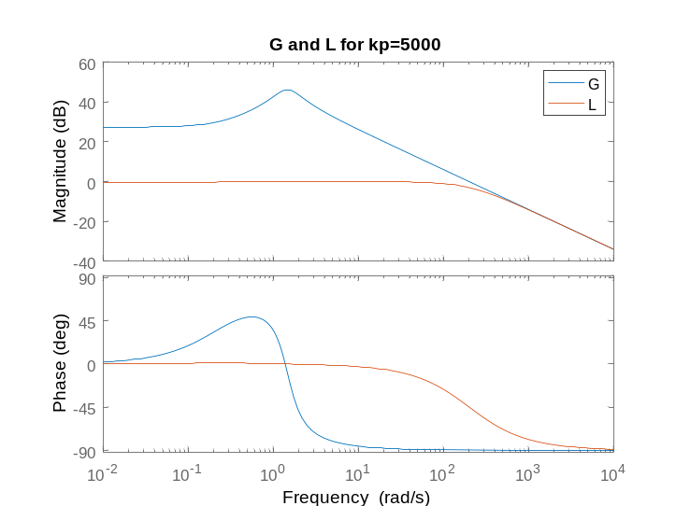
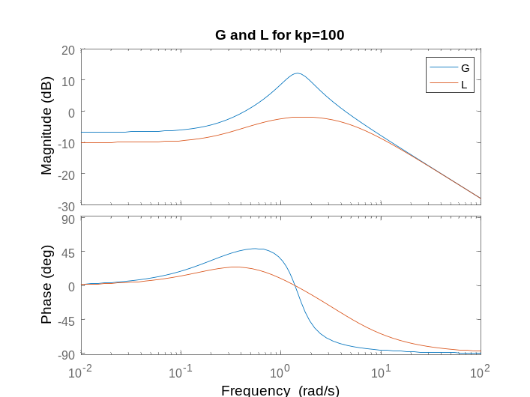
- Td=5

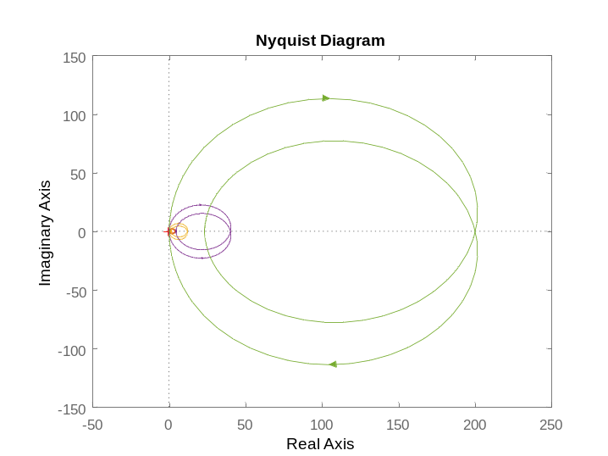
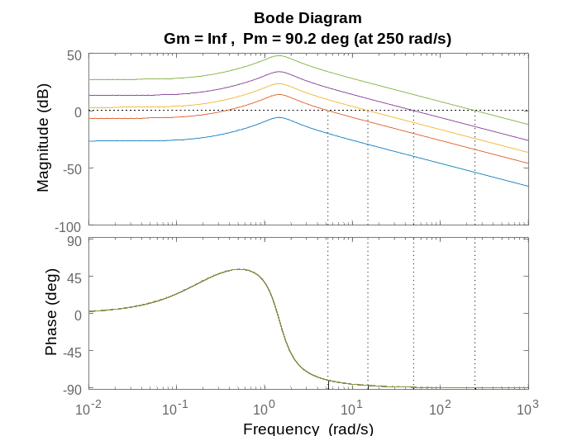

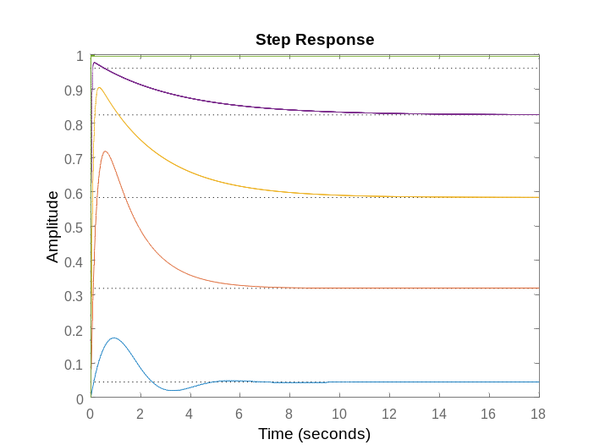
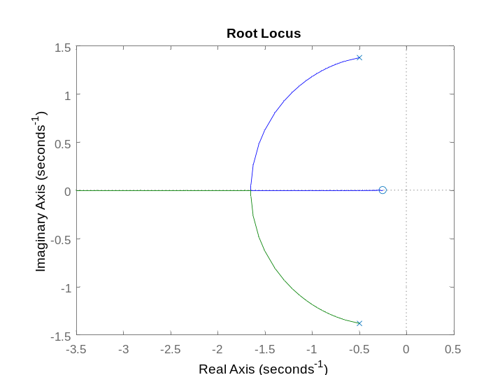
- Td=50
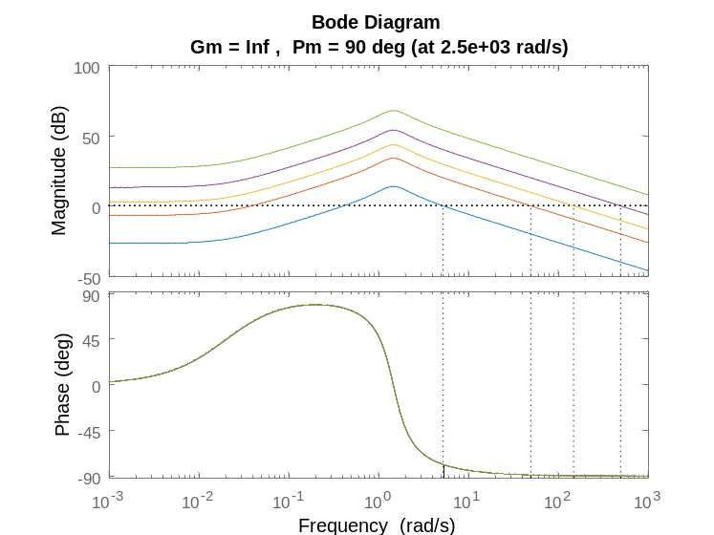
'kp' 'Steady-State Error' 'Bandwidth'
10 0.95559503 12.824913
100 0.68274112 17.277365
300 0.41770186 26.243278
1000 0.17709019 55.295872
5000 0.041263998 215.71228

PI-Control
- Ti=5
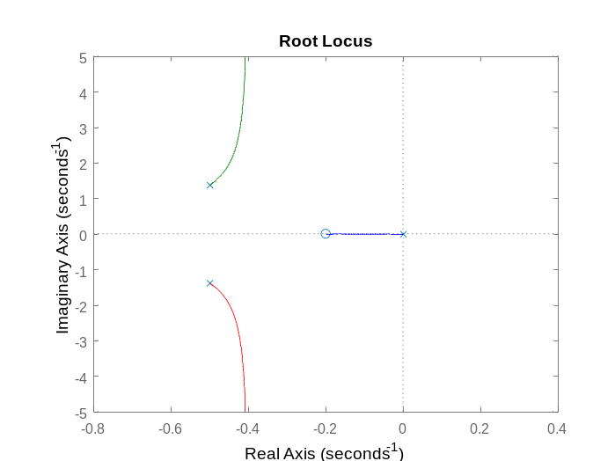
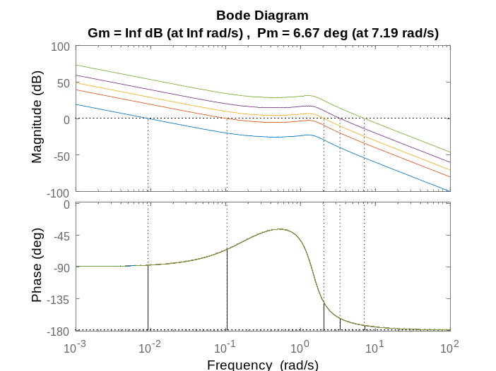

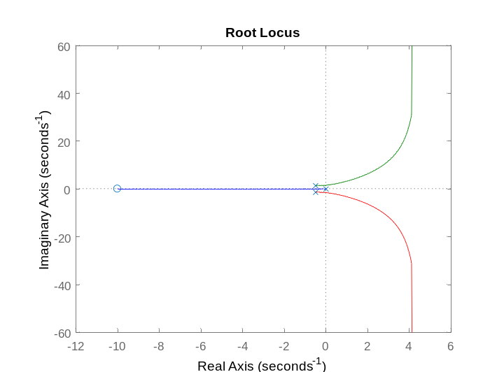
- Ti=0.1
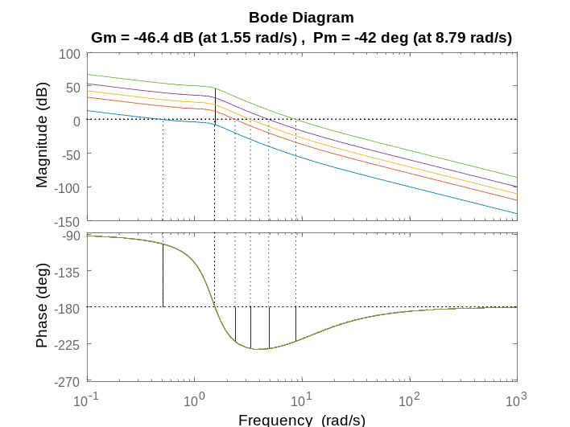

UNSTABLE SYSTEM: NEGATIVE DAMPING
r=-2.5 %[Ns/m]
kp_vect = [1 10 100 300 500]
PD-Control
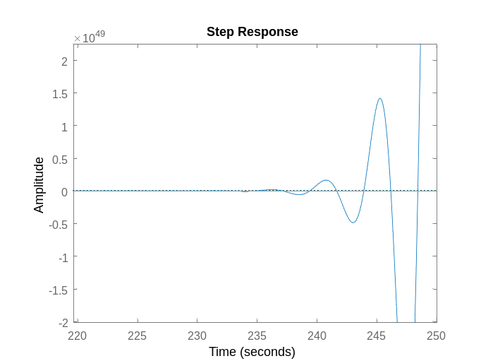
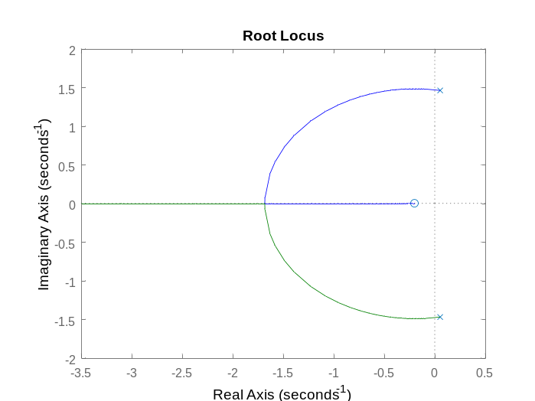
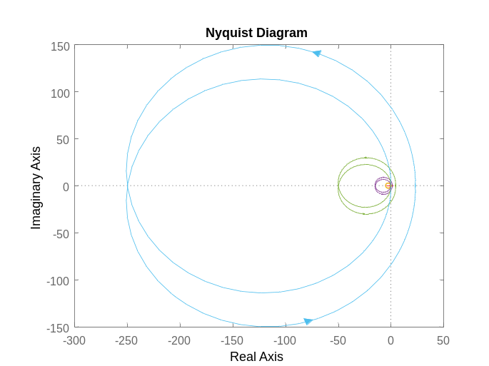

UNSTABLE SYSTEM: NEGATIVE STIFFNESS
P-Control
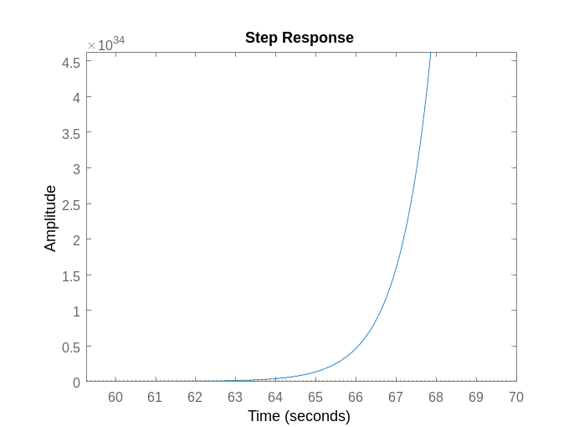
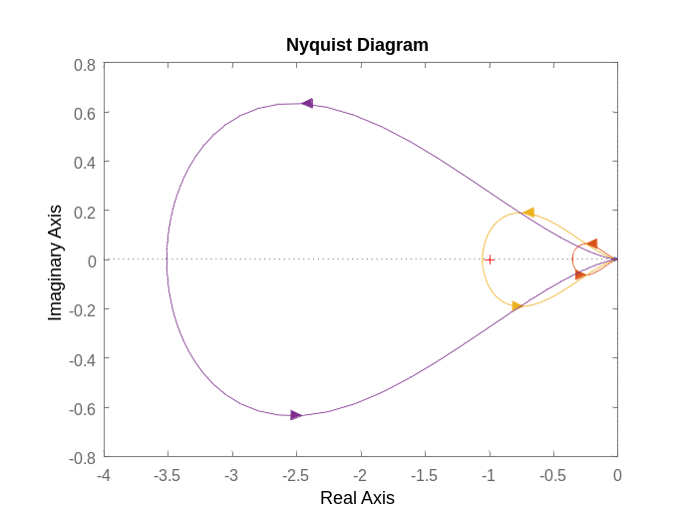

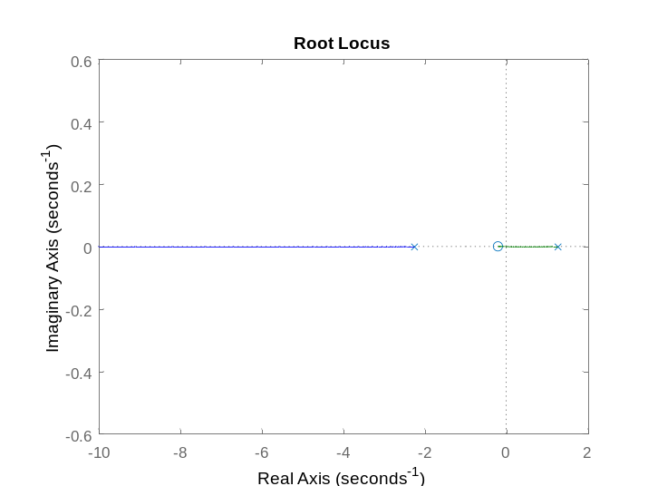
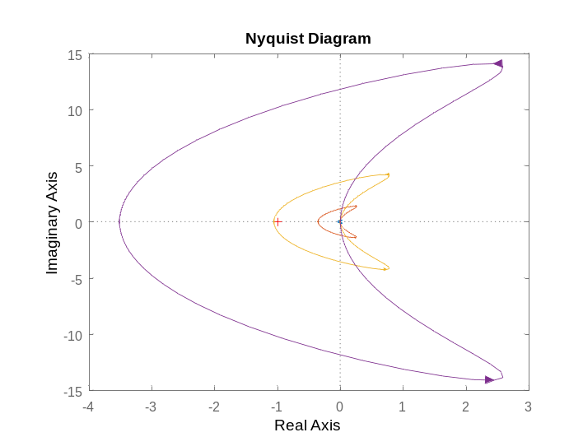
PD-Control
PI-Control
- Ti=20
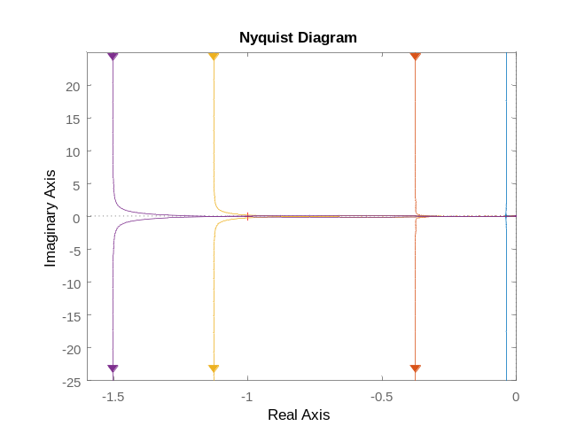
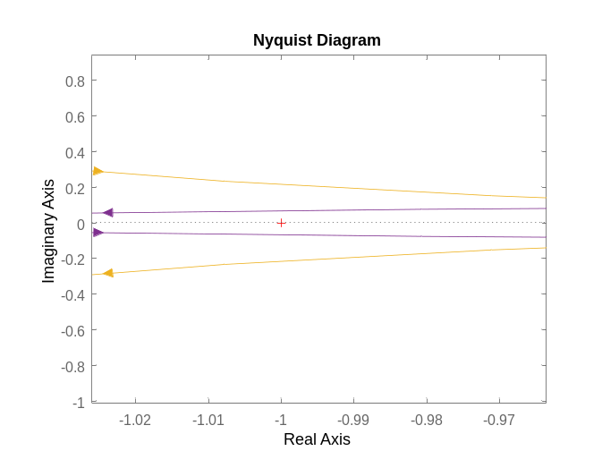
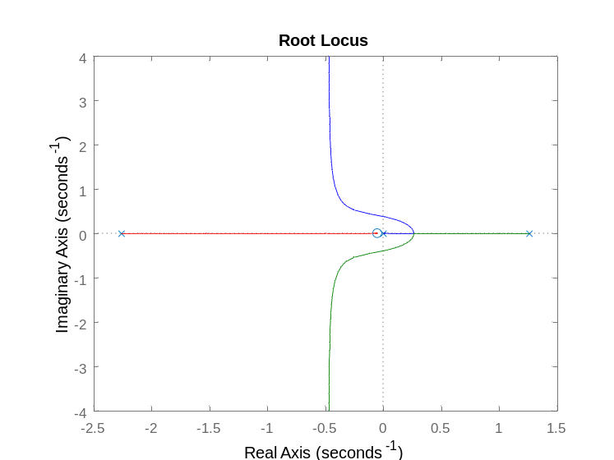
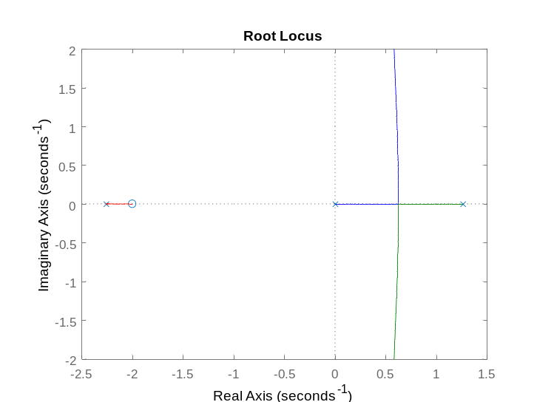
- Ti=0.5

STABLE SYSTEM with K*=0
P-Control
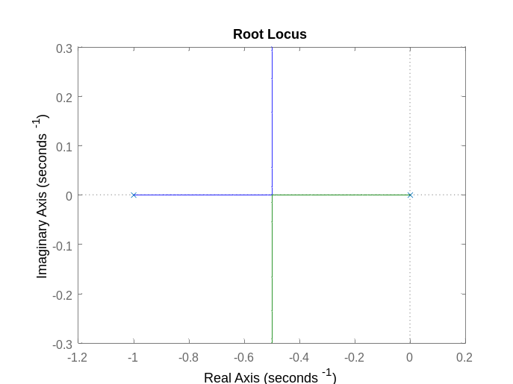
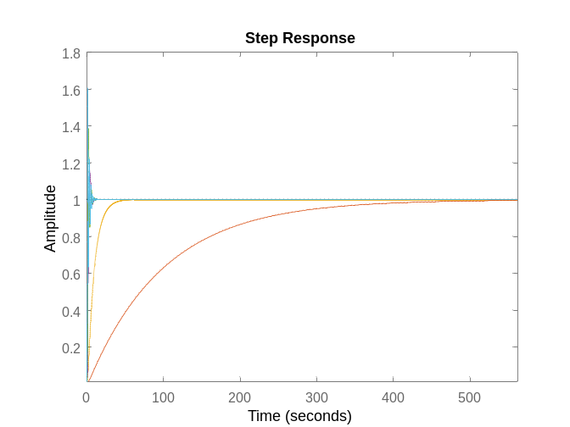
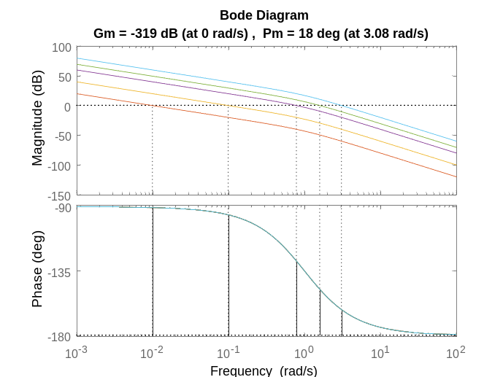
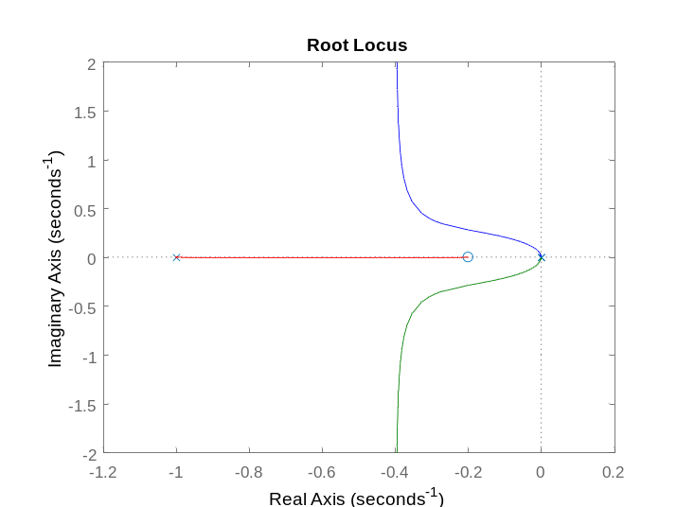
PI-Control

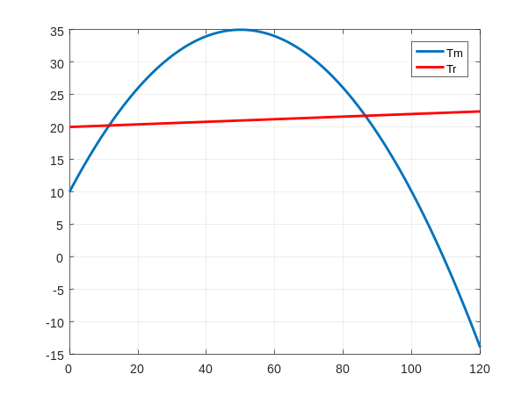
MOTOR AND RESISTANT TORQUE: VELOCITY CONTROL
Jm= 0.01; %[kg*m^2]
J= 0.15; %[kg*m^2]
r= 0.01; %[Ns/m]
kt = 1000; %[Nm/rad]
Tr = 20; %[Nm] constant
Tm= [-0.01 1 10]; %curva parabolica (a*w^2+b*w+c)*y

omega0 = roots([Tm(1) Tm(2)-2*r Tm(3)-Tr]);
omega0 = sort(omega0)

The linearization of Tm gives an equivalent dumping.
%I do not consider the derivtive control: the zeros due to control leads to a zero slope of GH at infinite with a bad result on response at high frequencies. Moreover it gives an equivalent mass wich increases the inertia and we get a slower system with worse performances.
STABLE CASE
1DOF
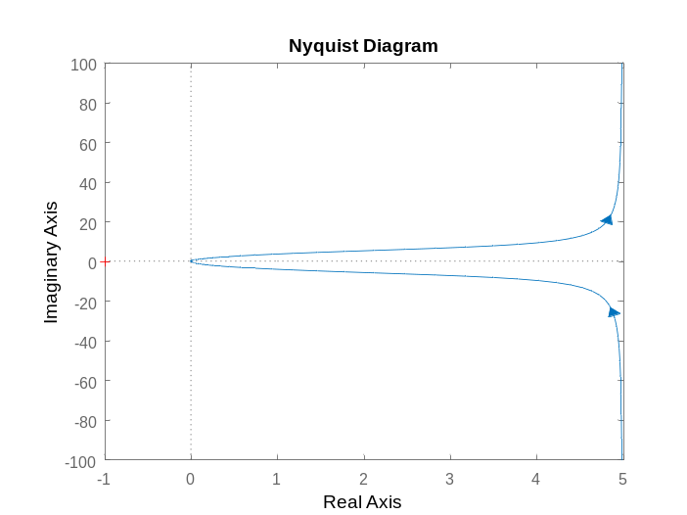
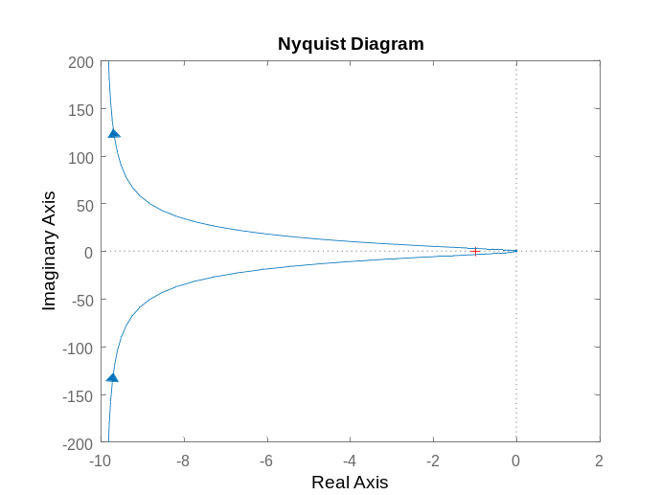
PI Ti=0.1 Ti=0.5
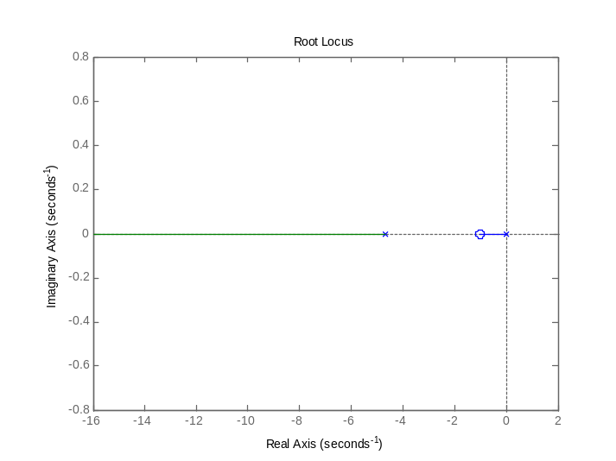
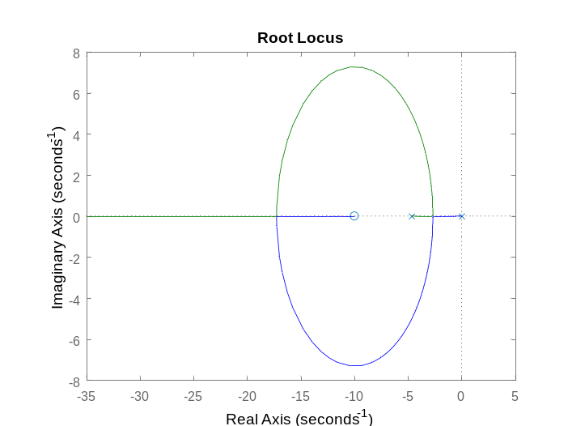

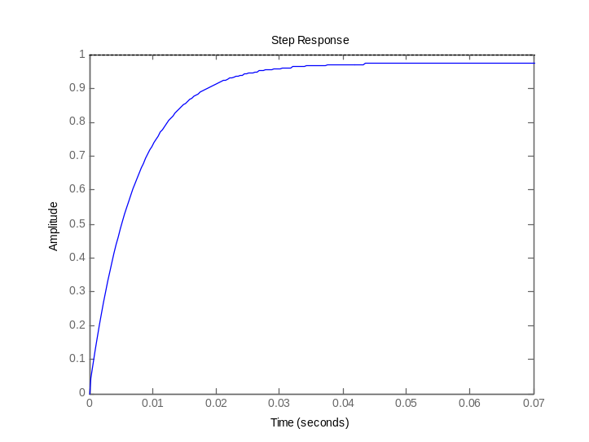
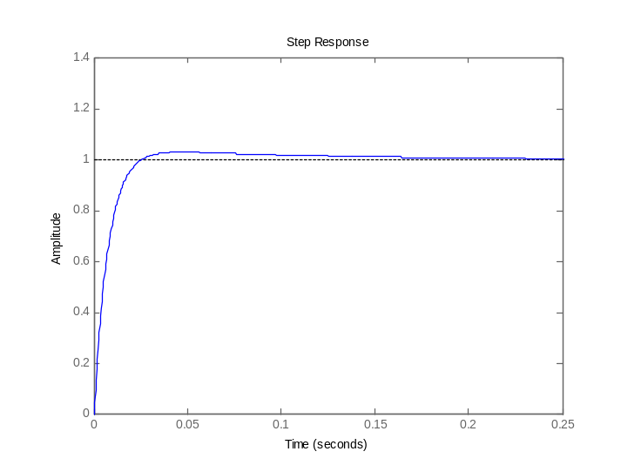
2 DOF
Colocated P-Control
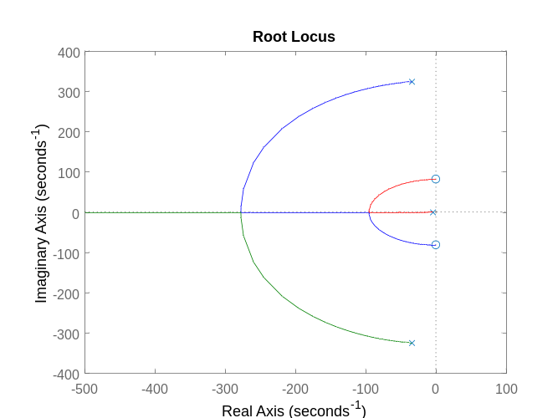
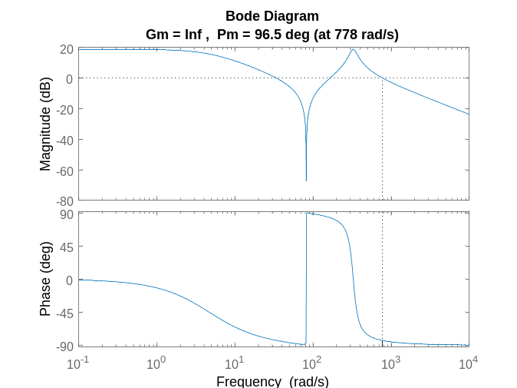
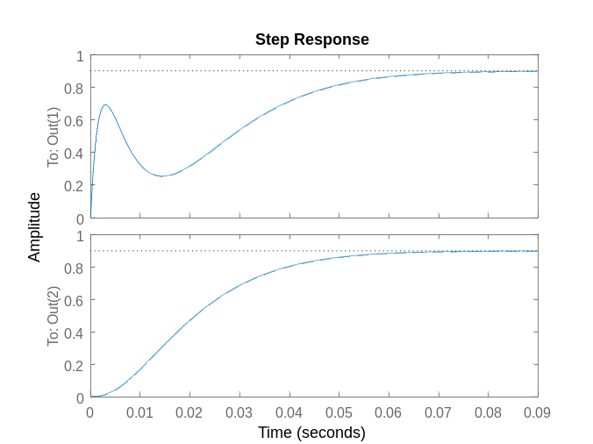

Non-Colocated P-Control
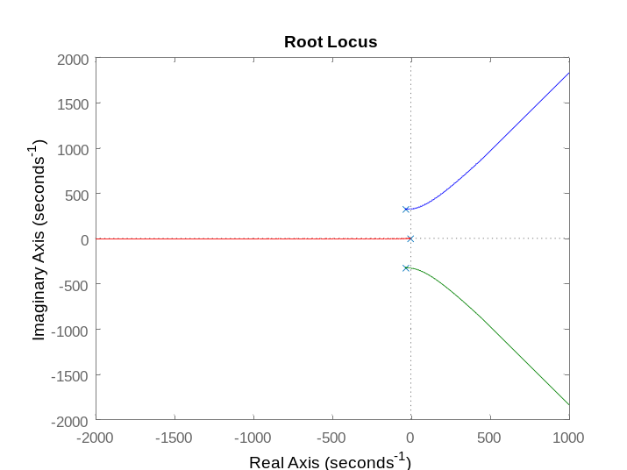
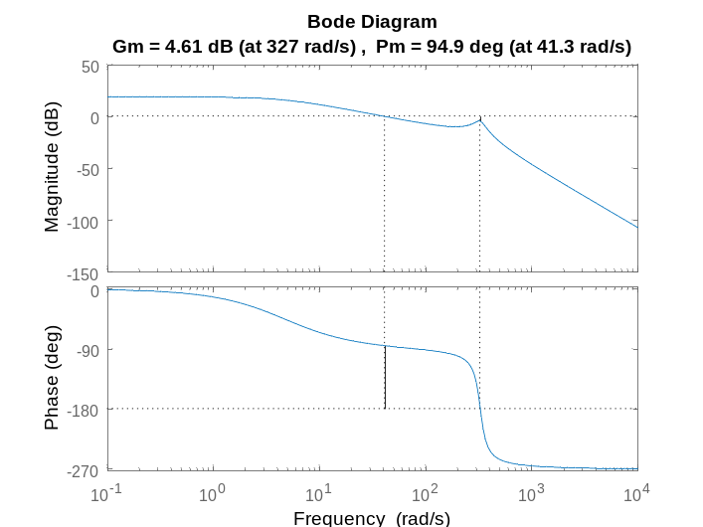
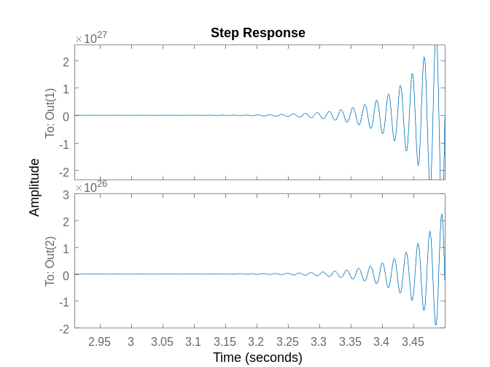
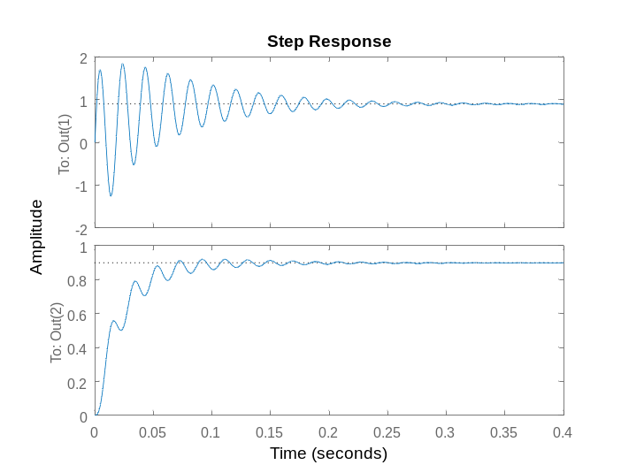
Large kp

Colocated PI-Control
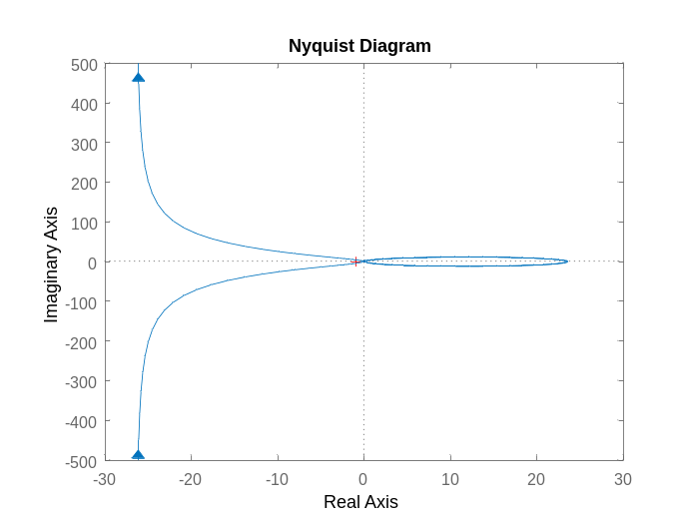
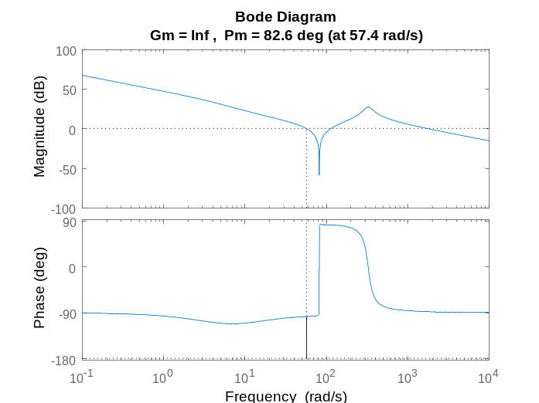

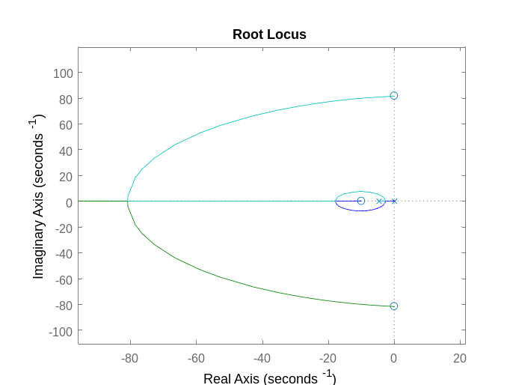
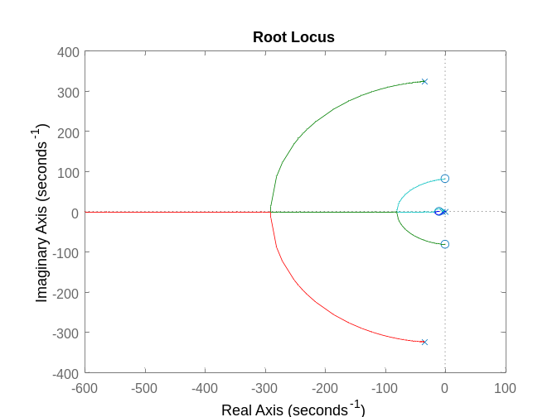
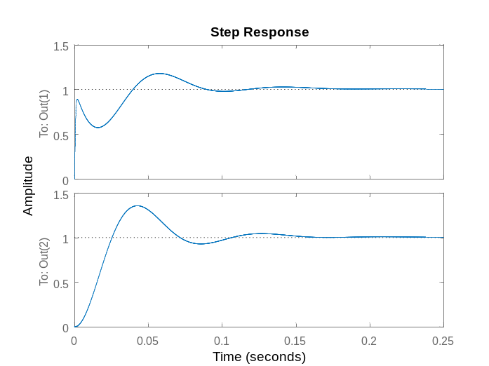
Non-Colocated PI-Control
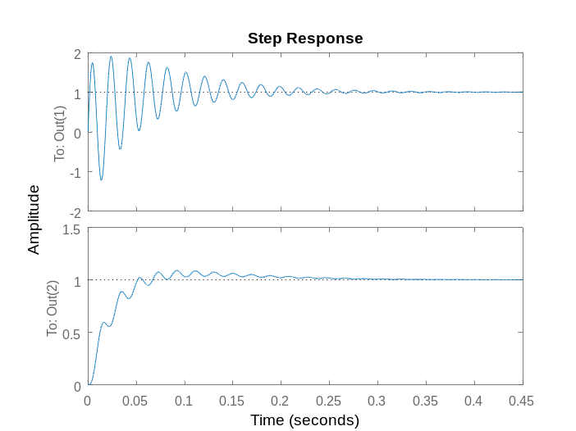
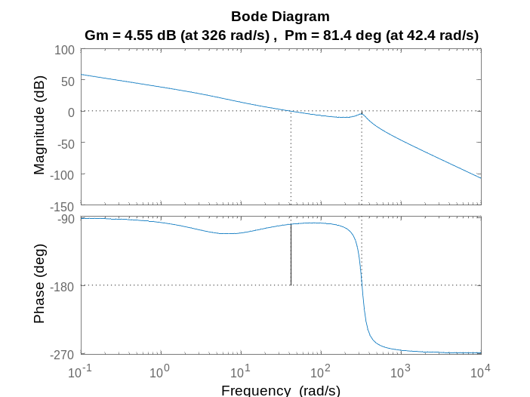
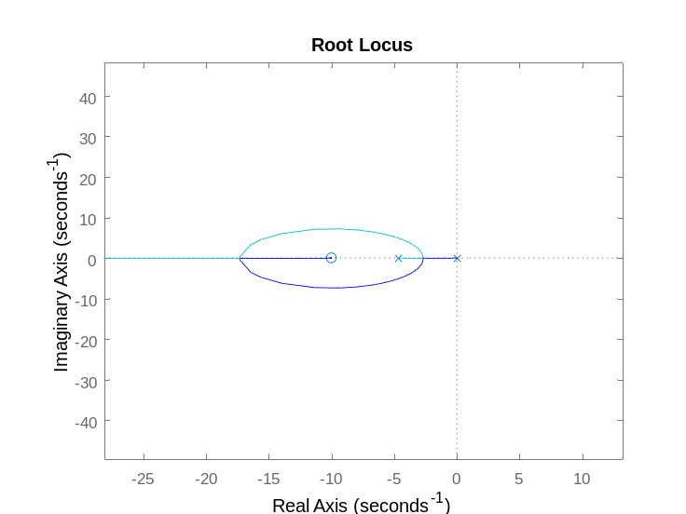
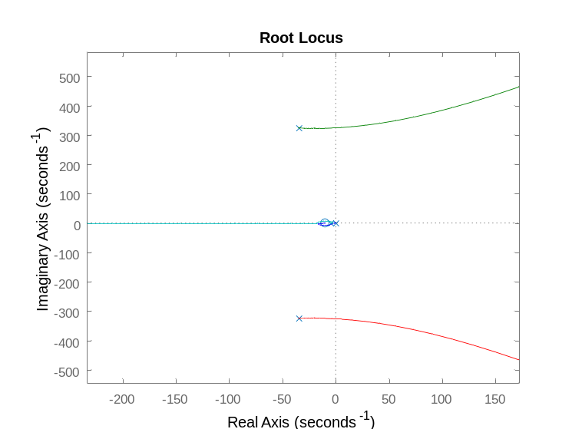
UNSTABLE SYSTEM
Colocated P-Control
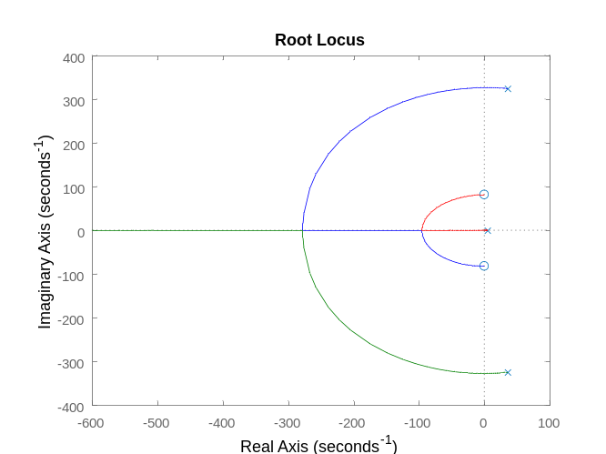
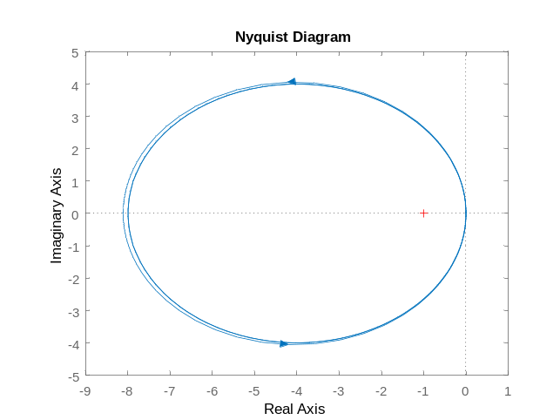
Non-colocated P-Control
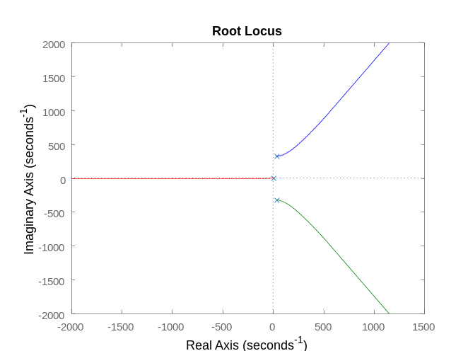
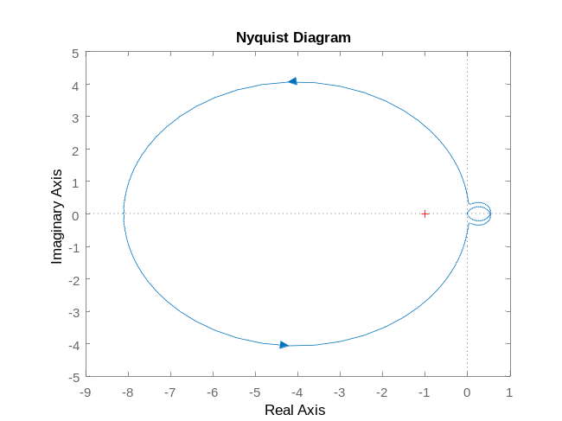

Colocated PI-Control
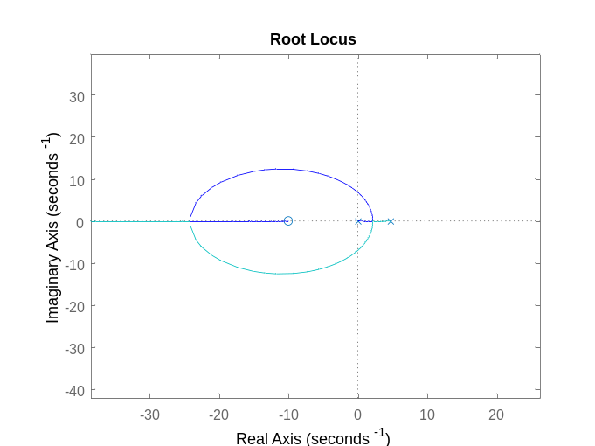
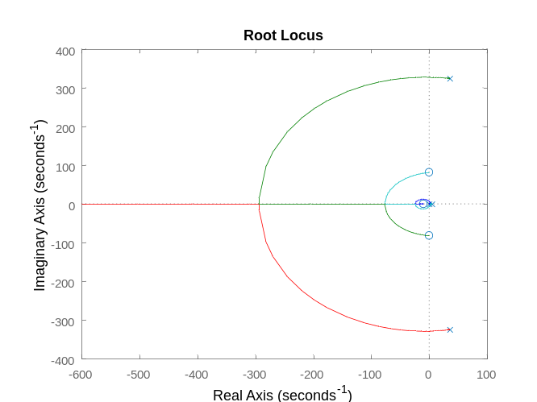
Non-Colocated PI-Control
